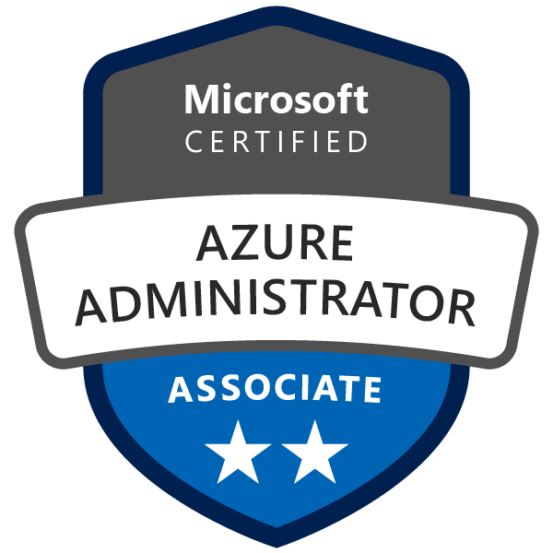
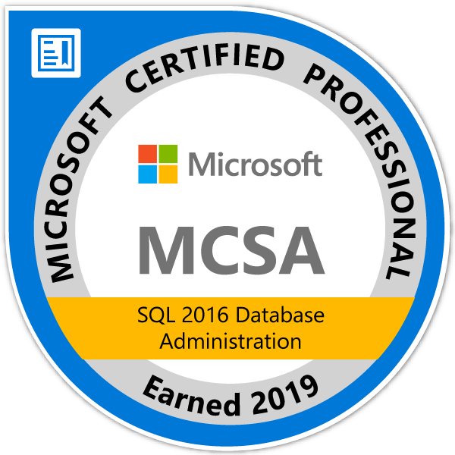
Naga Venkata Satish
nvssunkara@gmail.com
Mobile: +91 8553294558

Career objective:

Looking forward to a challenging job to utilize my database and management skills for the growth of organization and myself.

SUMMARY:

- Having 4+ Years of experience on MSSQL Server Database Administration and SQL Azure (IAAS & PAAS).
- Installing/troubleshooting SQL 2008R2/2012, 2014,2016,2017 & 2019 and its service packs.
- Experience in slipstream installation.
- Install/upgrade O.S with minimal user intervention through unattended installation
- Managing Security (Creating users, logins/roles, granting permissions at SQL Object level).
- Finding and Fixing Orphaned users through sp_change_users_login stored procedures.
- Experience in performing regular backups periodically and scheduling tasks.
- Experience in restoring database to Point-In-Time and Piecemeal Restore.
- Checking the status of backup and troubleshooting the failed backups.
- Creating Disaster Recovery Plan (Implemented DR Test).
- Good knowledge on Page Types, Understanding on internals of Page.
- Daily health checks on critical SQL Server instances including free space and error validation.
- Providing 24/7 On-Call support.
- Maintaining HA options like Log Shipping, Always on AG and Replication.
- Handling Log Shipping configuration/troubleshooting (14420, 14421 Errors).
- Implementing and troubleshooting Mirroring (1418 Errors).
- Performing the failover and failback operations in the Cluster environment.
- Monitoring Transactional Replication and troubleshooting sync issues.
- To analyze slow queries and tune with Indexes to optimize Apps/System performance.
- Improving query performance by creating Indexes and rebuilding as per fragmentation.
- Knowledge on different dynamic management views (DMVs).
- Using different DBCC Commands and Trace flags (3213, 3608, 3604, 3605, 1118 & 1117).
- Resolving Space Management issues like Temp-DB contention, Data and log file full issues.
- Handling detection and resolution of Blockings and Deadlock Issues by using Activity Monitor, SQL Commands and Profiler.
- Used Extended events for monitoring and troubleshooting blocking and deadlocking, finding long-running queries and tracking DDL operations.
- Troubleshooting connectivity issues (18456, SSPI Handshake errors).
- Rebuilding/restoring system databases and user databases.
- Fixing missing MSI & MSP files using tool.
- Good knowledge features like CDC, Data Compression, Backup compression, Resource Governor, Performance Data Collector, Backup Encryption and Transparent Data Encryption.
- Good knowledge on Query store.
- Configured Jobs for PAAS DB by using Elastic Jobs and Automation accounts.
- Migrated on premises DB to cloud using DMS.
- Configured SQL native alerts for Job status and SQL Server Health Checks using Agent Jobs.
- Configured Solar Winds for Monitoring SQL Server.
- Configured Reporting and Analysis Services. And good knowledge of migrating Reporting services Database.
- Good knowledge on Storage Accounts and VNET in Azure.
- Configured Virtual Machines along with SQL Server in Azure and Hypervisor.
- Migrated MySQL Databases from on premise to Azure IAAS VM.
- Creating and configuring Logins and permissions in MYSQL Database Server.
- Worked on creation of missing indexes in MYSQL Database Server to improve the query performance for critical databases.
- Good Knowledge on Performance Monitoring in MYSQL DB server using Workbench Tool.
- Knowledge on configuring of MYSQL DB server Configuration file.
- Configured MYSQL Agent Jobs through windows task scheduler to perform the MYSQL DB backups.
- Knowledge on AWS Cloud services.
- Worked on Migration of different DB Technologies MongoDB, MySQL & Oracle from On-Premise (Legacy) to AWS(MongoDB ,Document DB & AWS RDS Oracle).
• Worked on provisioning the DB servers using terraform.

Technical Skills:

SQL Server Tools : SSMS, Profiler, Perfmon, Extended Events,Workbench,IBM Datastudio,Compass,Robo3t,Studio3t,NoSQL Boosterz,DMA,Schema Conversion Tool
Databases :SQLServer2005-2019,AWSOracleRDS, MYSQL,MongoDB,DocumentDB,DB2
Languages : T-SQL
Operating Systems :WindowsXP/07/10&Servers 2008/08R2/2012/2016/2019,Linux

CERTIFICATIONS:

- MCSA 70 – 764 ‘Administering a SQL Database Infrastructure’ and MCSA 70-765 ‘Provisioning SQL Databases’ and AZ-104: Azure Administrator Associate.

Educational qualification:

- Bachelor of Technology (B.Tech) in Computer Science and Engineering from J.N.T.U, Kakinada.

WORK EXPERIENCE:

Currently working in Deloitte as a Cloud DB Migration Engineer from July-2022 to till date.

Professional Experience:

Project : Anthem
Role : Cloud Migration
Team Size : 9

Job Profile:

DBA Activities:
• Worked on Migration of different DB Technologies MongoDB, MySQL & Oracle from On-Premise (Legacy) to AWS (MongoDB ,Document DB & AWS RDS Oracle).
• Worked on provisioning the DB using terraform.
• Provisioning the MongoDB/ AWS RDS Oracle and creating users and granting roles.
• Configured OpsManager Agent for MongoDB and worked on Post Provisioning activities.
• Worked on creating customized roles to restrict the users from elevated privileges.
Migration Activities:
• Migrated MongoDB to AWS Document DB.
• Migrated Oracle DB from on Prem to AWS Oracle RDS DB by Dump and Restore method.
• Worked on Tokenized/Detokenized the PHI/PII data and Validating the Tokenized/Detokenized data.
• Worked on Conditional Tokenization and Migration of collections from On-Premises Mongo DB to AWS DOC DB.

WORK EXPERIENCE:

Marlabs Software Pvt Ltd, Bangalore, India
Duration: From March 2019 to July 2022.
ROLE: Worked as a MSSQL Database Administrator handling 24 * 7 Production servers, DB migrations and DB health monitoring.

Professional Experience:

Project : Shared Services with 7 clients GG (Gate Group), PROBONO, MDC MEDIA PARTNERS, MCO Central, ICL, Ultragenyx and supported Internal Servers
Role : SQL DBA
Team Size : 3

Job Profile:

- Creation of user databases and ensuring file group creations as per requirement.
- Create various database objects and create users with Fixed or Customized Server Roles and levels of security.
- Scheduled and maintain routine Jobs, Alerts and Maintenance Plans and setting up DB Mail.
- Performing SQL Server daily health check using DBCC commands and DMV’S.
- Checking the status of backup, troubleshooting failed backups and restoration of databases.
- Managing Backups on daily basis, Restore and Disaster Recovery procedures and recovering the databases from backup in disaster situations.
- Verifying all instances are up and running as per the checklist.
- Knowledge on Resolving System DB corruptions and Suspect DB troubleshooting.
- Have knowledge on clustering environment and monitoring through cluster administrator.
- Performing the failover and failback operations in the cluster environment.
- Migration of SQL Server 2008/2008R2/2012 to SQL Server 2014/2016/2017.
- Monitoring SQL performance using profiler to find performance and deadlocks.
- Monitoring Disk Space of all the Servers and freeing up space for cleanup.
- Reviewing SQL Server and SQL Server Agent Error Logs and troubleshoot the errors.
- Handling log file full and releasing space to OS by shrinking log files.
- Blockings, Deadlocks, Monitoring space issues Data File/Log File,
- Using Perfmon counters for monitoring CPU, Memory and IO issues.
- Experience in optimizing the query by creating various clustered, non-clustered indexes and indexed views.
- Experience in creating and configuring Azure SQL DB using Azure portal.
- Experience in working with Point in time DB restores in Azure.
- Configured Long Term Retention (LTR) backups for Mission critical databases.
- Configured on-premises SQL database backups to Azure using Microsoft Azure Backup tool.
- Creating logins, users and assigning the permissions to the users in Azure.
- Configured Active Geo Replication, Failover Groups using Azure portal.

